**DASHBOARD**

CREATE A DASHBOARD

|  |  |  |
| --- | --- | --- |
| Team Id | AD47707C5D4D5109D5E480002BDB30D5 | |
| Project Tittle | Build an Event Management System using salesforce |

1. Click the Dashboards tab.   
   2. Click New Dashboard.

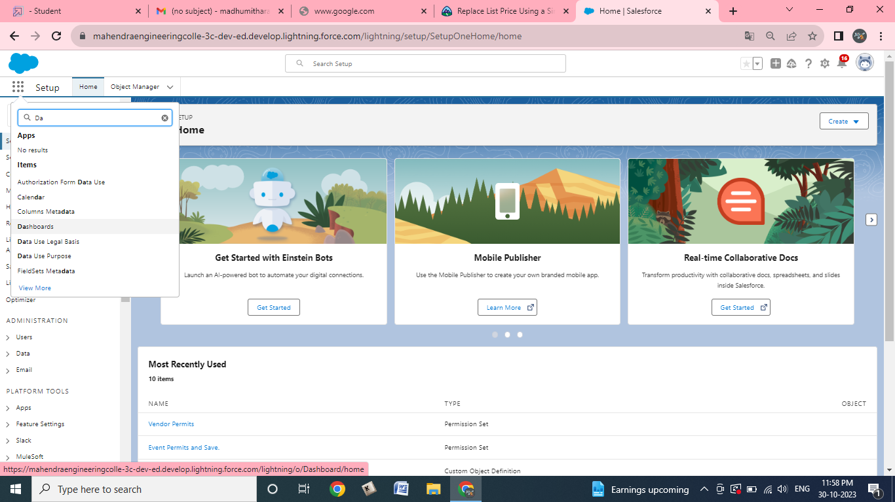

1. Name the dashboard Occasions with Attendees and click Create.   
   4. Click +Component.

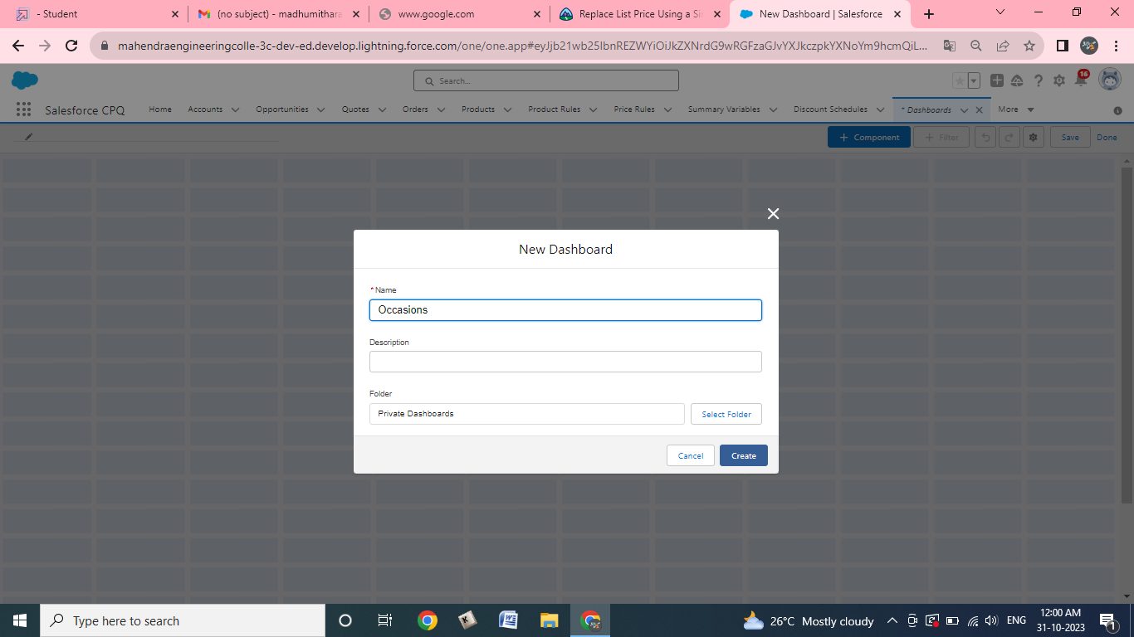

5. Select Occasions with Attendees and click Select.   
6. Select the Vertical Bar Chart component and click Add.

7. Click Save and then Done.

